SPH4U0 Newton’s Laws: Review Sheet

- Draw the action-reaction forces between the Moon and the Earth.

- Draw the action-reaction forces between a helicopter blade and the air.

3. Coyote and Roadrunner are involved in a tug of war. Coyote wins, pulling Roadrunner into a mud puddle. Why did Coyote win?

- Coyote exerted a greater force on the rope than Roadrunner.
- The rope exerted a greater force on Roadrunner than Coyote.
- Coyote exerted a greater force on the ground than Roadrunner.
- All of the above.

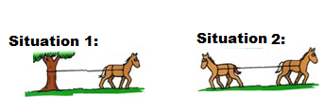
4. A rope has a breaking strength of 400 N. A horse which can pull with a maximum force of 350 N attempts to break a rope which is attached to a tree. The rope does not break. A second horse which can also pull with a maximum force of 350 N is brought in to help the first horse as shown below. Will the rope break? Explain.

Second Law: F_{net}= ma

- A 2.0 kg curling stone travelling at 5.0 m/s [East] strikes a second stone which is at rest. The collision lasts for 10.0 ms and the first stone’s velocity becomes 2.0 m/s [West]. Determine the net force on the first stone during the collision.

Gravity due to the Earth
F_{g}= mg g = 9.80 m/s²

- An 50.0 kg student rides up the LASS elevator with a recycling bin. If the elevator is moving at a constant velocity of 4.0 m/s [up], what is the normal force of the elevator floor on the student?

